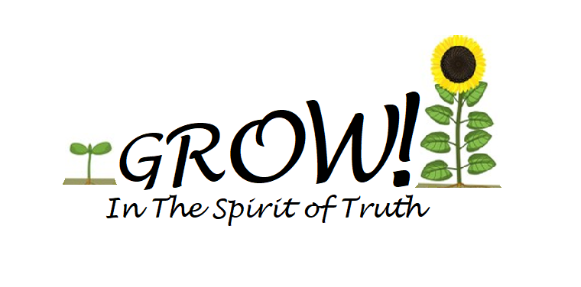
Vacation Bible School
Registration

2022 VBS will be held June 26th-29th, 6:00-8:00 P.M. At Spirit of Truth Lutheran Church
Please complete 1 form per child : Please Register by June 20th
Turn forms in at the church or e-mail to the church: spiritoftruthlutheranchurch@gmail.com

Child's name .
Grade completed Birthday Age______
Parents' names
Home address
Home phone Cell Phone________________________________________
Emergency contact person Relationship to student
Home phone Cell phone
Food allergies (circle) Y N (List:)
Medical concerns (circle) 'Y N Explain
Family doctor Doctor's phone
Siblings attending VBS (names and ages)
Church affiliation Church membership at: _____________________________________
People who may pick up the child

Release Form:
I/we understand that there are inherent risks involved in any activity, and I/we hereby release Spirit of Truth Lutheran Church and its leaders and volunteers from any and all liability due to any injury, loss, or damage to person or property that may occur during the course of child’s involvement with Spirit of Truth Lutheran Church.
I/we the undersigned, parents, or legal guardians of the above named participant, a minor, have given our consent for him/her to participate in an activity organized by Spirit of Truth Lutheran Church. In the event that he/she is injured while attending the activity and requires the attention of a doctor, I/we consent to reasonable medical treatment as deemed necessary by a licensed physician. In the event treatment is called for, which a physician and/or hospital refuses to administer without my/our consent, I/we hereby authorize one of the leaders of Spirit of Truth Lutheran Church to give such consent for us if I/we cannot be reached by phone at one of the numbers listed above, or because of an emergency, there is not time or opportunity to make a phone call. In the event it becomes necessary for that person to give consent for us, I/we will agree to hold such person free and harmless of any claim, demands or suits for damages arising from the giving of such consent. I/we also acknowledge that I/we will be responsible for the cost of all medical treatment.

I/we give Spirit of Truth permission to photograph/film the minor designated above for any lawful purpose associated with any Spirit of Truth program
* I/we understand that due to Covid 19 if my child is sick or has a fever, my child will not be allowed to attend. If my child becomes sick during programing I will be contacted and are expected to pick up my child immediately.
Parent's signature Date
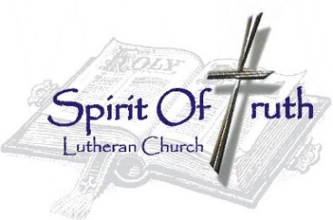
Spirit of Truth Lutheran Church
112 E Annabelle St. Brandon, SD 57005
605-582-5030 www.spiritoftruthsd.org

Parent Information:
Participation: All children are welcome at VBS. Any kids under 4 need to be accompanied at all times by an adult or sibling over 12. Teens participating will be Leaders or assisting with crafts, games, and snack time. Parents are welcome to participate as well. If you would like to help out for the day see any Group Leaders or the VBS Director.
**We will be painting during craft time at VBS. Please send your kids in clothing you do not mind them getting paint on.
Program Times: Scheduled VBS times are 6:00 – 8:00 P.M. Please be at the church by 8:00 to pick up your child/children.
Light Meal: A light dinner will be served from 5:15 – 5:45 P.M.
Sunday, Monday, & Tuesday dinners will be provided by Spirit of Truth Church
Wednesday’s meal will be pizza – Pizza will be $1.00 a slice and each participant needs to sign up for their pizza and pay by the end of VBS Tuesday night.

Church Contact Information:
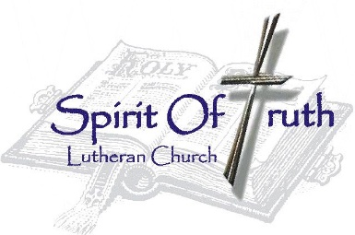
Spirit of Truth Lutheran Church
112 E Annabelle • Brandon, SD 57005
Phone: 582-5030
http://www.spiritoftruthsd.org

